3B Biological Sciences

Test 2 – Evolution

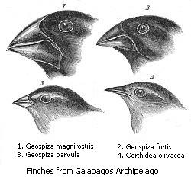

This test consists of two parts

Part A – Multiple Choice – 20 marks - use the separate answer sheet
Part B – Short Answer – 30 marks - write on the pages provided

PLEASE DO NOT MARK THIS question booklet

Part A – Multiple Choice (20 marks)

Mark the most correct response on the answer sheet provided

- The concept that life on Earth has slowly changed since the beginning of the Earth’s history over millions of years ago is known as

  - transitions
  - evolution
  - natural selection
  - succession.

- Charles Darwin proposed a theory of how evolution occurred by a concept known as natural selection. This concept is based on the idea that

  - favourable variations gradually become more common in the population
  - organisms that survive reproduce their favourable characteristics
  - there is variation within a species
  - all of the above.

- A new species can arise in a number of ways. The most important step which can produce a new species is described by which of the following?

  - prevention of interbreeding by a geographical barrier
  - adaptation to a new environment
  - sudden appearance of new forms which then multiply
  - selection of individuals with particular characteristics

- A mutation is best described as

  - a new characteristic appearing in an organism
  - a permanent change in genetic material
  - a change in the mitotic process
  - treatment by radiation.

- Cells can be produced in a number of ways depending upon the type and function of the cell. Cell division that produces gametes is known as?

  - mitosis
  - meiosis
  - cleavage
  - reproduction

- When talking about population genetics a favourite term for biologists to use is ‘gene pool’. What does this term refer to?

  - a barrier of some kind which prevents gene flow
  - The total genes within the overall population being studied
  - removal of genes from a population by any means
  - evolution from a common ancestor to form a new population

7. Most fossil remains are of aquatic rather than terrestrial organisms.
Which one of the following is the best explanation for this?

a) Aquatic organisms have more hard parts in their bodies than terrestrial organisms.

b) Sedimentary rocks are not formed in a terrestrial environment.

c) Dead terrestrial organisms are more likely to decompose than dead aquatic ones.

d) Dead aquatic organisms are more likely to become covered with sediments

8. The range of normal differences that occur between siblings of the same family is known as

a) variation
b) adaptation
c) mutation
d) evolution

9. Darwin believed that the finch species found on the Galapagos Island all developed from a common ancestor due to their many physical and behavioural similarities. This speciation was most probably a result of

a) natural evolution.
b) geographical isolation
c) behavioural isolation
d) ecological isolation

10. Convergent evolution :

a) is the evolution of similar features in closely related species

b) explains the similarity of an octopus eye and a fish eye

c) occurs when related species become different over time

d) explains the different beak shapes in the Galapagos finches

11. The human embryo has gill slits at an early stage in its development as do all other
vertebrate embryos. This supports the idea that

a) all vertebrates must be somehow related
b) humans are closely related to fish
c) all vertebrates are meant to live underwater
d) fish and man belong in the same genus

12. Frequencies of most genes within a population are maintained by the process of

a) natural selection
b) migrations
c) isolation
d) random interbreeding

13. The wings of a bat and the wings of a butterfly function for flying. In terms of evolution, these
structures are best described as

a) homologous

b) analogous

c) divergent

d) the same

14. Which of the following cannot produce variation?

a) mitosis
b) mutations
c) meiosis
d) environmental changes

15. In the Origin of Species Charles Darwin wrote

“Although in oceanic islands the species are few in number, the proportion of endemic kinds (i.e. those found nowhere else in the world) is often extremely large. If we compare, for instance, the number of endemic land-shells in Madeira or of endemic birds in the Galapagos Archipelago, with the number found on any continent, we shall see that this is true.”

This observation is best considered an example of

  - speciation through mutation
  - variation within a species
  - specific creation
  - speciation through isolation

16. From the following statements select which one gives the least support for the modern theory of evolution.

a) Fossil organisms similar to present-day organisms differ from the latter in certain features.
b) All chordates have structural similarities
c) All mammals develop gill pouches during their embryonic development
d) There are many protozoans in the world today

17. Fossils include

a) insects trapped in amber

b) footprints preserved in mudstone

c) an impression of a leaf in a rock

d) all of the above

18. Sub-species are sometimes described as a stage in development of new species. Which of the following conditions would NOT facilitate formation of two new species?

  - Reproductive isolation of members of one race from another.
  - Interbreeding between members of each race to produce fertile hybrid offspring
  - Increasing differences between members of each race leading to separate gene pools.
  - Each race tending to be confined to geographical areas with differing environmental factors operating.

19. After an area was sprayed with the insecticide DDT, it was found that some populations of mosquitoes were resistant to DDT. The best explanation for this was that

a) Mosquitoes naturally resistant to DDT are more likely to survive and reproduce
b) DDT causes individual mosquitoes to become resistant to DDT
c) Mosquitoes that become resistant to DDT as a result of the spraying produce offspring resistant
to DDT
d) DDT acts on a particular gene causing it to produce an enzyme which destroys DDT

20. The Dunkers are a religious group that moved from Germany to Pennsylvania in the mid-1700s. They do not marry with members outside their own immediate community. Today, the Dunkers are genetically unique and differ in gene frequencies from all other populations including their original homeland. Which of the following likely explains the genetic uniqueness of this population?
a) sexual selection and mutation
b) mutation and natural selection
c) founder effect and genetic drift
d) geographic isolation and random mating
3B Biological Sciences Test 2 – Evolution
Name _______________________________________________________________________

Part B – Short Answer 30 marks

1. When Charles Darwin first established his theory of evolution by natural selection he noted that there were differences between individuals within a population, but did not understand why. Since then the discovery and study of genetics has lead to a greater understanding of the mechanisms that cause variation within a population.

  - Name the process illustrated below and state how it increases genetic variation

Crossing over during meiosis (1)
Paired chromosomes swap pieces which results in new combinations(1)
2 marks
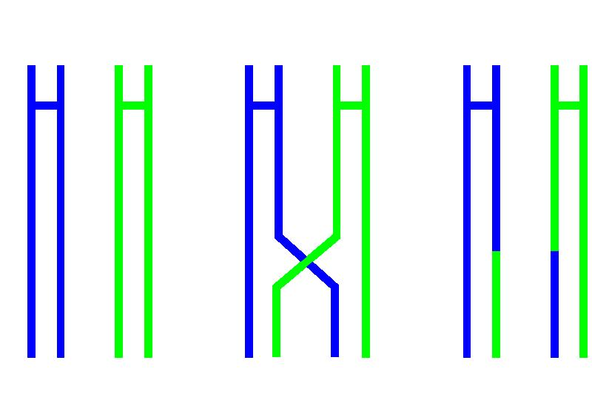
b) Describe how independent assortment during meiosis causes variation between siblings

When paired chromosomes line up at metaphase and move apart they do this independently from each other(1)
This means that gametes that form the siblings will have a variety of paternal and maternal chromosomes (1)
2 marks
c) Describe another way that variations may arise from meiosis

Mutations which are genetic mistakes (1)
Base pairs(point) mutations, gene and parts of chromosomes, even whole chromosomes may be copied incorrectly (1)
Results in new genotypes and therefore phenotypes which may be beneficial, neutral or cause disadvantages(1) any two
Non-disjunction and explanation
2 marks

2. The Ngorongoro Crater was formed when a giant volcano exploded and collapsed on itself some two to three million years ago. It is 610 m (2,001 ft) deep and its floor covers 260 km² (102 square miles). It is thought of as "a natural enclosure" for a very wide variety of wildlife. An effect of this 'enclosure' situation means that the population of Ngorongoro lions is severely inbred, with many genetic problems passed from generation to generation. This is due to the very small amount of new bloodlines that enter the local gene pool, with very few migrating male lions entering the crater from the outside.

In 1962, the Crater lions suffered an epizootic (animal epidemic) that reduced the population to nine females and one male. An additional seven males apparently immigrated into the Crater in 1964–1965, but there has been no further immigration into the Crater in the past 25 years. By 1975, the population had recovered to its current level of 75-125 animals. All members of the current Crater population are descended from only 15 founders. The Crater was probably colonized by lions from the nearby Serengeti ecosystem and the current Crater lion population shows a significant lack of genetic diversity compared to the much larger Serengeti population.

- Name the isolating mechanism of this population and describe the effect it has had on allele
frequency.
Geographic isolation (1)
It restricts gene flow from outside the crater (1)
OR a low diversity of genes / high frequency of the same genes due to inbreeding(1)
2 marks

b) Describe the effect that natural selection and genetic drift may have had on this population.

The disease selected the fittest lions ( resistant to disease) which survived (1)
These lions then went onto breed (1) passing on their resistant genes to the next generation(1)
Genetic drift would eliminate the least frequent alleles (1)
4 marks
c) Discuss two selective pressures and how these may lead to extinction of this population of
lions.

Diseases / epizootic such as described (1)
Climate change (1) OR competition for food/ mates (1)
May lead to extinction as there is
Lack of diversity in the gene pool / inbreeding (1)
Low chance of new alleles arriving due to isolation (1)
None survive (1) 4 marks

3. A group of Australian scientists has decided to breed a population of brush-tailed possums that make suitable domestic pets. Brush-tailed possums are naturally nocturnal and can be aggressive towards humans.
Describe in a series of steps the selective breeding process the scientists would use to “produce” a population of possums that are diurnal (active during the day) and affectionate towards humans.
Artificial selection (1)
Breed possums from a wide variety (1)
Select individuals that are affectionate towards humans (1)
Breed only from these (1)
Repeat this process with possums that are more diurnal than nocturnal (1)
4 marks
4. The description of evolutionary relationships (phylogeny) has changed markedly since the development of comparative biochemical studies.

- Explain why phylogenetic studies were previously limited by the use of structural characteristics only.
Modern biochemical techniques had not been invented (1)
Structural characteristics easily observed from collected/ dead /preserved specimens (1)
2 marks

b) Describe how modern biochemical methods including DNA studies have improved phylogenetic studies and provided evidence for evolution.
Biochemical/ protein studies e.g. Cytochrome C or Haemoglobin comparisons
a brief description of the technique (1) How it provides evidence for evolution (1)
DNA hybridisation / comparisons brief description (1)
How it provides evidence for evolution (1)
4 marks

5. Parts (a) and (b) of this question refer to the diagram below.

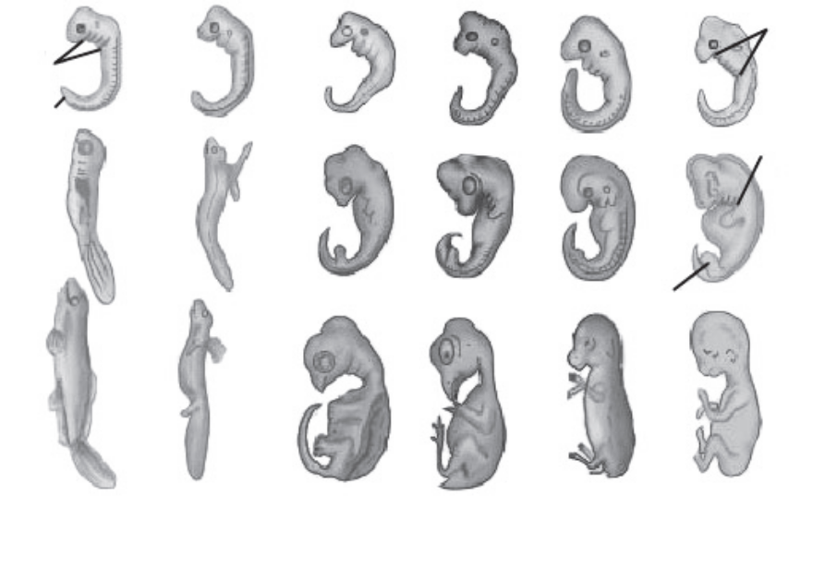
Gill
slits

Gill-slits

Tail
Fore-limb bud

Hind-limb bud

Fish Salamander Tortoise Chick Rabbit Human

a) Name and describe the specific type of study shown above used to provide evidence for evolution.
Comparative embryology (1)
Embryos from different vertebrate groups can be compared to show homologous structures, indicating common ancestors or relatedness (1)

2 marks

b) Describe one other homologous structure in vertebrates which can be used for evidence for evolution.
Vertebrate pentadactyl limb, (1)
Different vertebrate groups have the same basic structure/ bones in their forelimbs indicating a common ancestor (1)
2 marks

- The figure below shows the average reproductive success (average number of offspring) in male and female elephant seals at different ages.

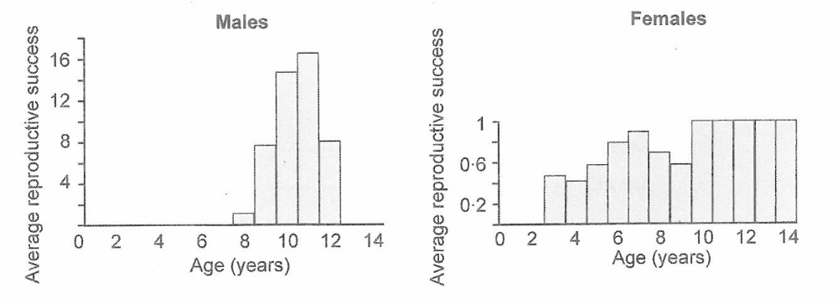
  - Compare the patterns in reproductive success in male and female elephant seals.

Females begin reproduction at an earlier age / males at a later age
Females are reproductively successful over a longer period of time (2-14 years) while males have a shorter reproductive life (8-12 years)
Females produce only one offspring per year while males can produce many more (up to 17)
ANY 2 POINTS
2 marks

  - Male elephant seals are substantially larger than female elephant seals. Sexual selection is mainly responsible for this difference. Explain how sexual selection has led to larger male elephant seals.
Large males compete successfully against other males OR large males are preferred as a mate by the females
Large males have more offspring
Increase of frequency of genes for larger males
3 marks

